Functional Test Report for
PMS Revamp 1.3.0-beta.4
30th Jan 2026


Document History
It outlines the strategy used to ensure a comprehensive evaluation.

Version | Author | Date | Review | Affected Sections
V1.0 | Swetha N | 30/01/2026 | Ragini Krishnamurthy

Contents

1 Introduction 4
1.1 Overview and Scope 4
2 Test Approach 4
3 Test Organization 5
3.1 Test Planning 5
3.2 Sanity Scenarios Verified 5
3.3 Test Environment 6
4 Test Execution Report 8
4.1 Test case execution summary 8
4.2 Automation Results 9
Detailed Test metrics 10
5 Test Execution Report 10
5.1 Browser compatibility evaluations 10
5.2 Screen sizes used for UI responsiveness validation 11
6 Feature Health 11
Known Issues Metrics 11
Sonar Report 12
7 Conclusion 13
7.1 QA Approval 13
8 Appendix 14
8.1 Appendix A: Versions 14
8.2 Appendix B: Acronyms 14

Introduction
The Partner Management System Revamp testing scope includes the following: Features: MISP Partner, ABIS Partner, Authentication Partner, Device Partner, FTM Partner, Partner Admin, Certificate Trust Store, Partners, Policies, Partner-Policy Linking, SBI-Device, FTM Chip, Authentication Services, User Profile, User Dashboard, Root CA Certificate expiry notifications, Intermediate Certificate expiry notifications, Partner Certificate expiry notifications, API Key expiry notifications, FTM Chip expiry notifications, SBI ID expiry notifications, and Weekly Summary notifications for Partner Certificate, API Key, FTM Chip, and SBI ID expiry.

Overview and Scope
The scope of testing defines the boundaries, functionalities, and features that will be tested for the Partner Management System (PMS) Revamp. This ensures comprehensive validation of critical workflows while clearly identifying what is included and excluded from testing.
Functional Features: MISP Partner, ABIS Partner, Authentication Partner, Device Partner, FTM Partner, Partner Admin, Certificate Trust Store, Partners, Policies, Partner–Policy Linking, SBI–Device Mapping, FTM Chip, Authentication Services, User Profile, User Dashboard.
Cross-Platform Support:
- Multilingual: English, Arabic, French
- Multi-Browser: Edge, Firefox, Chrome
- Devices: Windows, Mac, Tablet, Mobile, Extra-large screens
- Testing Types: Sanity, Regression Testing and Integration Testing
- Cross-browser and cross-device compatibility testing.

Test Approach
The scope of testing is to verify fitment to the specification from the perspective of
Functionality
Combination
UI Automation
API automation
Library verification

Test Organization
Table 1: Test Organization
Name | Functional Role | Responsibilities
Ragini Krishnamurthy | Manager | Defining test strategy, managing QA activities, and ensuring overall product quality.
Chandra Sekhar | Lead | Leading the test team, planning and executing tests, and ensuring timely delivery of quality results.
Swetha N  Rachana S P | Test engineers | Designing and executing test cases, performing functional and regression testing, verifying PMS module functionality, logging and tracking defects, and validating fixes to ensure quality standards.

Test Planning
This Test Plan outlines the testing approach, scope, resources, and schedule for the Partner Management System (PMS) Revamp. The objective is to ensure that all functional, integration, and non-functional requirements are met with high quality before release.
- Validate end-to-end functionality of the Partner Management System Revamp.
- Ensure system stability across supported browsers, devices, and languages.
- Verify integrations with dependent systems and services.
- Identify and mitigate risks early through regression and integration testing

Sanity Scenarios Verified
Sanity testing will be performed to ensure basic application stability before detailed test execution. The following high-level sanity scenarios will be verified:
- Application accessibility and successful login for different partner roles
- Core partner creation and management flows (MISP, Device, Auth, FTM and ABIS Partner)
- Partner–Policy linking
- Authentication services basic validation
- Certificate upload and validation
- Notification triggers for certificate/API key expiry (basic check)
- User profile and dashboard accessibility
Only upon successful completion of sanity testing will the build be accepted for full regression and integration testing.

Test Environment
https://qa-core.mosip.net/
Table 2: Test Environment -images
Tested on qa-core env with components
docker.io/mosipid/admin-service:1.2.1.1
docker.io/mosipid/admin-ui:1.2.0.1
docker.io/mosipid/apitest-auth:1.2.1.1-beta.1
docker.io/mosipid/apitest-esignet:1.6.2
docker.io/mosipid/apitest-idrepo:1.2.2.2
docker.io/mosipid/apitest-masterdata:1.2.1.2
docker.io/mosipid/apitest-resident:1.2.1.2
docker.io/mosipid/artifactory-server:1.2.0.2
docker.io/mosipid/artifactory-server:1.2.0.3
docker.io/mosipid/artifactory-server:1.3.0-beta.1
docker.io/mosipid/artifactory-server:1.4.1-ES
docker.io/mosipid/authentication-internal-service:1.2.1.0
docker.io/mosipid/authentication-otp-service:1.2.1.0
docker.io/mosipid/authentication-service:1.2.1.0
docker.io/mosipid/biosdk-server:1.2.0.1
docker.io/mosipid/commons-packet-service:1.2.0.1
docker.io/mosipid/config-server:1.1.2
docker.io/mosipid/consolidator-websub-service:1.2.0.1
docker.io/mosipid/credential-request-generator:1.2.2.0
docker.io/mosipid/credential-service:1.2.2.0
docker.io/mosipid/data-share-service:1.2.0.1
docker.io/mosipid/esignet-with-plugins:1.6.2
docker.io/mosipid/esignet:1.4.1
docker.io/mosipid/hotlist-service:1.2.1.1
docker.io/mosipid/id-repository-identity-service:1.2.2.0
docker.io/mosipid/id-repository-salt-generator:1.2.0.1
docker.io/mosipid/id-repository-vid-service:1.2.2.0
docker.io/mosipid/kernel-auditmanager-service:1.2.0.1
docker.io/mosipid/kernel-auth-service:1.2.0.1
docker.io/mosipid/kernel-idgenerator-service:1.2.0.1
docker.io/mosipid/kernel-keymanager-service:1.3.0-beta.3
docker.io/mosipid/kernel-masterdata-service:1.2.1.1
docker.io/mosipid/kernel-notification-service:1.2.0.1
docker.io/mosipid/kernel-otpmanager-service:1.2.0.1
docker.io/mosipid/kernel-pridgenerator-service:1.2.0.1
docker.io/mosipid/kernel-ridgenerator-service:1.2.0.1
docker.io/mosipid/kernel-salt-generator:1.2.0.1
docker.io/mosipid/kernel-syncdata-service:1.2.1.1
docker.io/mosipid/keycloak-init:1.2.0.1
docker.io/mosipid/keys-generator:1.2.0.1
docker.io/mosipid/minio-client-util:latest
docker.io/mosipid/mock-abis:1.2.0.2
docker.io/mosipid/mock-identity-system:0.11.2
docker.io/mosipid/mock-identity-system:0.9.3
docker.io/mosipid/mock-mv:1.2.0.2
docker.io/mosipid/mock-relying-party-service:0.11.2
docker.io/mosipid/mock-relying-party-service:0.9.3
docker.io/mosipid/mock-relying-party-ui:0.11.2
docker.io/mosipid/mock-relying-party-ui:0.9.3
docker.io/mosipid/mock-smtp:1.0.0
docker.io/mosipid/mosip-artemis-keycloak:1.2.0.1
docker.io/mosipid/mosip-file-server:1.2.0.1
docker.io/mosipid/oidc-ui:1.4.1
docker.io/mosipid/oidc-ui:1.6.2
docker.io/mosipid/partner-onboarder:1.2.0.1
docker.io/mosipid/postgres-init:1.2.0.1
docker.io/mosipid/pre-registration-application-service:1.2.0.1
docker.io/mosipid/pre-registration-batchjob:1.2.0.1
docker.io/mosipid/pre-registration-booking-service:1.2.0.1
docker.io/mosipid/pre-registration-captcha-service:1.2.0.1
docker.io/mosipid/pre-registration-datasync-service:1.2.0.1
docker.io/mosipid/pre-registration-ui:1.2.0.1
docker.io/mosipid/print:1.2.0.1
docker.io/mosipid/registration-client:1.2.0.2
docker.io/mosipid/registration-processor-common-camel-bridge:1.2.0.2
docker.io/mosipid/registration-processor-dmz-packet-server:1.2.0.2
docker.io/mosipid/registration-processor-notification-service:1.2.1.1
docker.io/mosipid/registration-processor-registration-transaction-service:1.2.0.2
docker.io/mosipid/registration-processor-reprocessor:1.2.0.2
docker.io/mosipid/registration-processor-stage-group-1:1.2.0.2
docker.io/mosipid/registration-processor-stage-group-2:1.2.0.2
docker.io/mosipid/registration-processor-stage-group-3:1.2.0.2
docker.io/mosipid/registration-processor-stage-group-4:1.2.0.2
docker.io/mosipid/registration-processor-stage-group-5:1.2.0.2
docker.io/mosipid/registration-processor-stage-group-6:1.2.0.2
docker.io/mosipid/registration-processor-stage-group-7:1.2.0.2
docker.io/mosipid/resident-service:1.2.1.1
docker.io/mosipid/resident-ui:0.9.1
docker.io/mosipid/softhsm:v2
docker.io/mosipid/websub-service:1.2.0.1
docker.io/mosipqa/activemq-artemis:1.1.5
docker.io/mosipqa/apitest-esignet:develop
docker.io/mosipqa/apitest-pms:1.3.x
docker.io/mosipqa/certmanager:develop
docker.io/mosipqa/dsl-orchestrator:1.3.x
docker.io/mosipqa/dsl-orchestrator:develop
docker.io/mosipqa/dsl-packetcreator:1.3.x
docker.io/mosipqa/dsl-packetcreator:develop
docker.io/mosipqa/inji-verify-service:develop
docker.io/mosipqa/inji-verify-ui:develop
docker.io/mosipqa/partner-management-service:1.3.x
docker.io/mosipqa/pmp-ui-v2:1.3.x
docker.io/mosipqa/policy-management-service:1.3.x
docker.io/mosipqa/postgres-init:develop
docker.io/mosipqa/uitest-pmp-v2:1.3.x
docker.io/mosipqa/uitest-resident:develop
mosipid/apitest-esignet:1.6.2
mosipid/config-server:1.1.2
mosipid/keycloak-init:1.2.0.1
mosipid/postgres-init:1.2.0.1
mosipid/softhsm:v2
mosipqa/apitest-esignet:develop
mosipqa/postgres-init:develop
mosipqa/uitest-pmp-v2:1.3.x
mosipqa/uitest-pmp-v2:release-1.3.x

Test Execution Report
Below are the test metrics by performing functional testing. The process followed was black box testing which based its test cases on the specifications of the software component under test. The functional test was performed in combination with individual module testing as well as integration testing. Test data were prepared in line with the user stories. Expected results were monitored by examining the user interface. The coverage includes GUI testing, System testing, End-To-End flows across multiple languages and configurations.

Test case execution summary
The Test Case Execution Summary section provides a detailed overview of the total test cases executed across platforms, including pass, fail, and skip counts. It includes a table summarizing results and observations on execution pass rates.
Table 3: Test Case - Manual Verification (UI):

Total | Passed | Failed | Skipped (N/A)
7272 | 7254 | 40 | 33
Test Rate: 99% with Pass Rate: 99.7%

Note: NA - 33 Test Cases which are descoped scenarios/not developed feature

Table 4: Test Case - Manual Verification (API):

Total | Passed | Failed | Skipped (N/A)
1249 | 1237 | 2 | 10
Test Rate: 100% with Pass Rate: 100%

Note: NA - 6 Test Cases which are descoped scenarios/not developed feature

Automation Results
This section provides a summary of the automated test execution. It shows the pass, fail, and known issues from the automated test suite.
Table 5: Automation Execution Result -API Testrig
Total | Passed | Failed | Skipped (N/A) | Ignored | Known issues
1485 | 1485 | 0 | 0 | 0 | 0
Test Rate: 100% with Pass Rate: 100%

Note- API flow is tested through automation for both positive and negative scenarios, while test cases that are not automated are tested manually.
Table 6: Automation Execution Result - UI Automation
Total | Passed | Failed | Skipped (N/A) | Ignored | Known issues
88 | 88 | 0 | 0 | 0 | 0
Test Rate: 100% with Pass Rate: 100%

Detailed Test metrics
Below are the detailed test metrics by performing Manual/automation testing. The project metrics are derived from Defect density, Test coverage, Test execution coverage, test tracking and efficiency.
The various metrics that assist in test tracking and efficiency are as follows:
- Passed Test Cases Coverage: It measures the percentage of passed test cases. (Number of passed tests / Total number of tests executed) x 100
- Failed Test Case Coverage: It measures the percentage of all failed test cases. (Number of failed tests / Total number of test cases executed) x 100

Test Execution Report
Verification is performed on various configurations as mentioned below
- Default configuration with verified configuration for 3 Lang (English/Arabic/French)

5.1 Browser compatibility evaluations
- Table 7: Browser versions tested on desktop/laptop
Sl.No | Browser | Versions
1 | Chrome | Version 144.0.7559.110
2 | Firefox | Version 147.0.2
3 | Edge | Version 144.0.3719.92
4 | Safari | Version 18.6 (20621.3.11.11.3

- Table 8: Browser versions tested on tablet device
Sl.No | Browser | Versions
1 | Chrome | Version 144.0.7559.110
2 | Firefox | Version 147.0.2
3 | Edge | Version 144.0.3719.92
- Table 9: Browser versions tested on extra-large screens
Sl.No | Browser | Versions
1 | Chrome | Version 144.0.7559.110
2 | Firefox | Version 147.0.2
3 | Edge | Version 144.0.3719.92
4 | Safari | Version 18.6 (20621.3.11.11.3)

5.2 Screen sizes used for UI responsiveness validation
- Laptop/Desktop: 1920x1080
- Tablet: 1280X800
- Extra-large screens: 3840x2160
- Mac book: 2560 x 1664

Feature Health

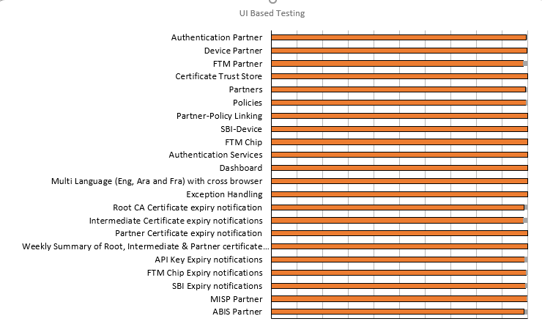

Known Issues Metrics
This section focuses on a separate category of issues that are known but not addressed in the current release. It provides a count and severity distribution for these defects across releases.
Table 10: Defect Metrics for the known issues
Blocker | Critical | Major | Minor | Total
0 | 0 | 12 | 28 | 40

Sonar Report
- Partner-Management-Service:
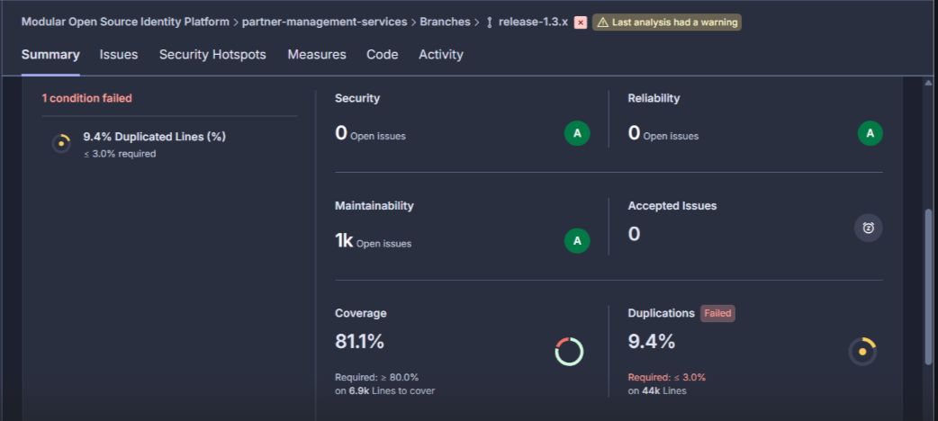
- Partner- Management-Portal:

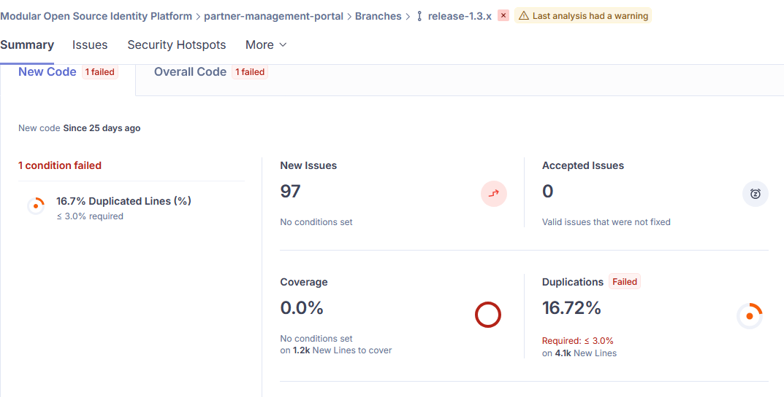

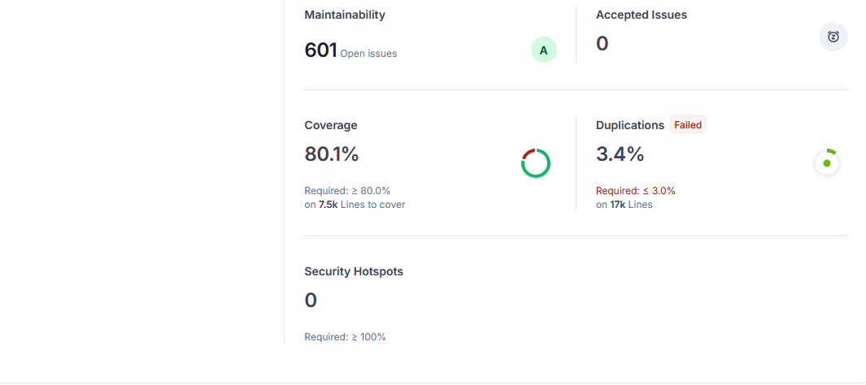

Conclusion
The Partner Management System (PMS) Revamp version 1.3.0-beta.4 has been successfully validated in the qa-core environment, with all critical functionalities performing as expected.
Sanity, regression, and integration testing were completed within the defined scope.
- No critical or high-severity defects remain open.
- Based on the successful test execution and results, QA approves the build for release.

QA Approval
The build has met all the defined exit criteria and is recommended for release based on the following:
- Test Case Execution: All planned test cases have been executed successfully.
- Story and Defect Closure: All user stories are completed, and no critical or high-severity defects remain open.
- Automation Reports: API-Testrig and UI automation execution reports have been reviewed and approved.
- Documentation Sign-off: All required test and release documentation has been reviewed and signed off.
- Test Environment Stability: The test environment remained stable throughout the testing cycle.

Table 11: Report is signed off details
Name | Functional Role | Responsibilities
Ragini Krishna | Manager | Defining test strategy, managing QA activities, and ensuring overall product quality.
Chandra Sekhar N | Lead | Leading the test team, planning and executing tests, and ensuring timely delivery of quality results.

Appendix
This includes additional reference information for the report. It contains a history of document versions and a list of acronyms and their meanings.

Appendix A: Versions
Version | Date | Author | Reviewers
V1.0 | 30/01/2026 | Swetha N | Ragini Krishna

Appendix B: Acronyms
Acronym | Literal Translation
SBI  FTM  ABIS | Secure Biometric Interface  Foundational Trust Module  Automated Biometric Identification System

END OF DOCUMENT

